Documentation for CRUSH Interface

Todd Blank and Leen-Kiat Soh

August 7, 2003

Computer Science and Engineering
University of Nebraska
115 Ferguson Hall
Lincoln, NE 68588-0115

CRUSH System

The following is our CRUSH system. This report documents the CRUSH Deliverer Interface. This interface serves two purposes. First, it delivers lectures (tutorials, examples, and problems) to the student. Second, it monitors the keyboard and mouse actions of the student. This information is useful in the reasoning module of the CRUSH Intelligent Agent. The agent reasons on what types of examples and problems to deliver to the student based on the information. In addition, the agent also updates its databases to store the information about the tutorial and the student.

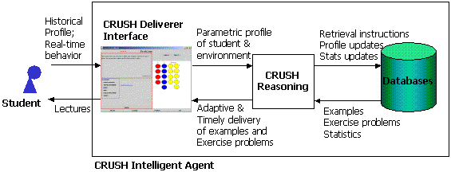

Overall Flow

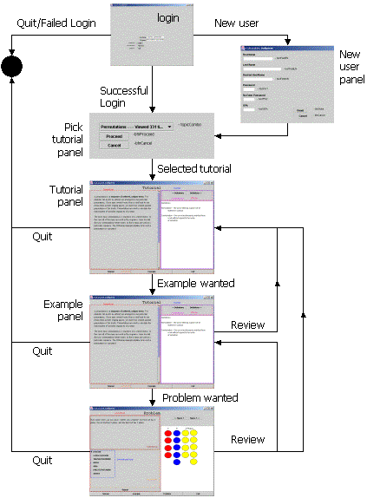

The Login Panel
  - Purpose:
    - This panel allows a student to login as a registered user or as a new user. This is the first panel of the CRUSH Deliverer software.
  - Diagram:

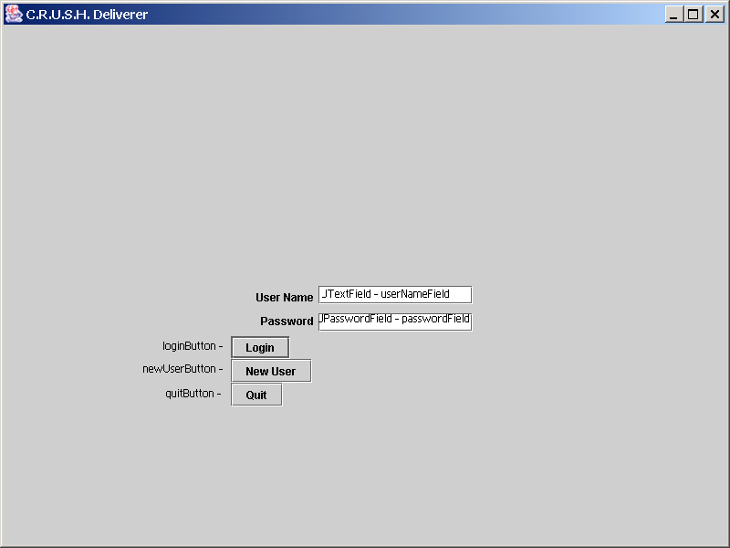

  - Use:
    - loginButton – Queries the Database and checks the given username with the given password, and proceeds to PickTtrlPanel if successful
    - newUserButton – This is used to go to the newUser Panel, to create a new student profile in the database, which can then be used to logon with.
    - QuitButton – disposes of the JFrame, exiting the program. This is the ONLY way to quit the program, thus preventing students from disposing of the program before the program can update the database and the agent.

The New User Panel
  - Purpose:
    - This panel allows a new student to register and supply some personal information
  - Diagram:

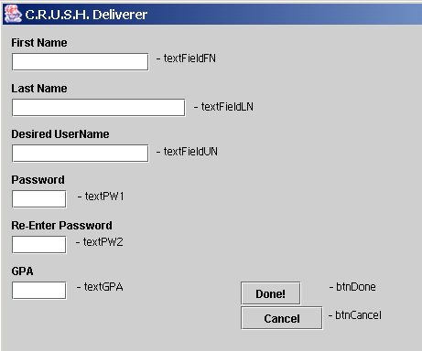

  - Use
    - TextFields (e.g., textFieldFN, textFieldLN, textFieldUN, textPW1, textPW2, and textGPA) – respective text fields for fields to be filled in the database
    - btnDone – checks to make sure passwords match, all fields are filled in, and GPA is a number between 0 and 4. If they do, it adds the user to the database, and returns to the login screen. If they do not they are given an error message corresponding to what needs to be corrected.
    - BtnCancel – returns to the login screen without adding the user to the database

The PickTutorial Panel
  - Purpose
    - This panel allows the user to pick one tutorial topic and proceed.
  - Diagram

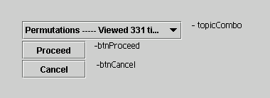

  - Use
    - TopicCombo – Populated by the database with the active topics the student can view, along with how many times the student has viewed them
    - BtnProceed – proceeds to the Tutorial of the specified topic
    - BtnCancel – returns to the login screen

The Tutorial Panel
  - Purpose
    - This is one of the two most comprehensive panels in the CRUSH Deliverer interface. It displays the tutorial on the topic previously selected by the student. It has a main window for the content of the tutorial, a secondary window for additional information (definitions, graphics, etc.) We call this secondary window “Xcontent” window. In addition to the two windows, the panel also has an Example button for the user to click to proceed to the example panel. All mouse and keyboard actions of the user will be tracked and captured by our agent working behind-the-scene.
  - Diagram

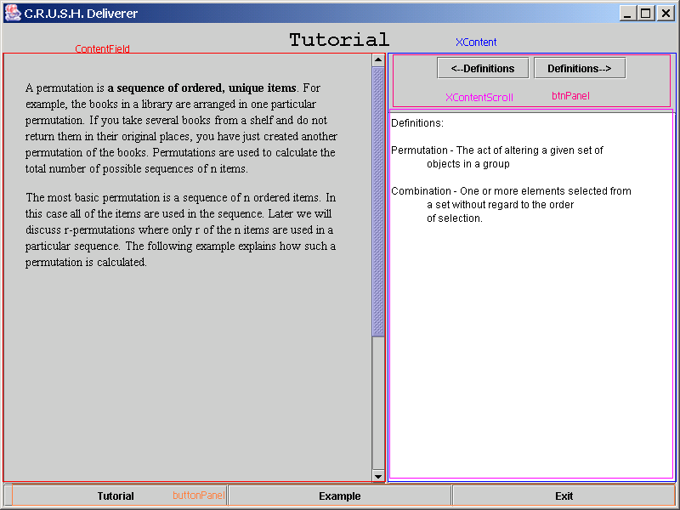
  - Explanation
    - ContentField – Holds the content of the Tutorial, can be plain text, or HTML
    - XContent, holds btnPanel and xContentScroll, for the support Material
    - BtnPanel – two buttons, for navigating between the support material
    - XContentScroll, holds the support material, by opening a PHP page that is passed the ID of the support material to get. The support material can be text, HTML, a JPEG, or a GIF.
    - ButtonPanel – buttons to navigate within the interface, exit returns to the login screen.

The Example Panel
  - Purpose
    - It displays the example (selected dynamically by our CRUSH agent).
  - Diagram
    - This is the same as the Tutorial Panel except that it now adds a new button for access to the Problem Panel. All mouse and keyboard actions of the user will be tracked and captured by our agent working behind-the-scene.

The Problem Panel
  - Purpose
    - This is one of the two most comprehensive panels in the CRUSH Deliverer interface. It displays the problem (selected by our CRUSH agent based on the tracked actions of the user) to the user. It has three windows. A content window holds the question of the problem. An Answer panel holds the answers of the problem. A “Xcontent” window displays graphics related to the problem. After the student submits an incorrect answer, the panel will give a feedback to the student before exiting (Note to Todd: Is this true?). All mouse and keyboard actions of the user will be tracked and captured by our agent working behind-the-scene.
  - Diagram

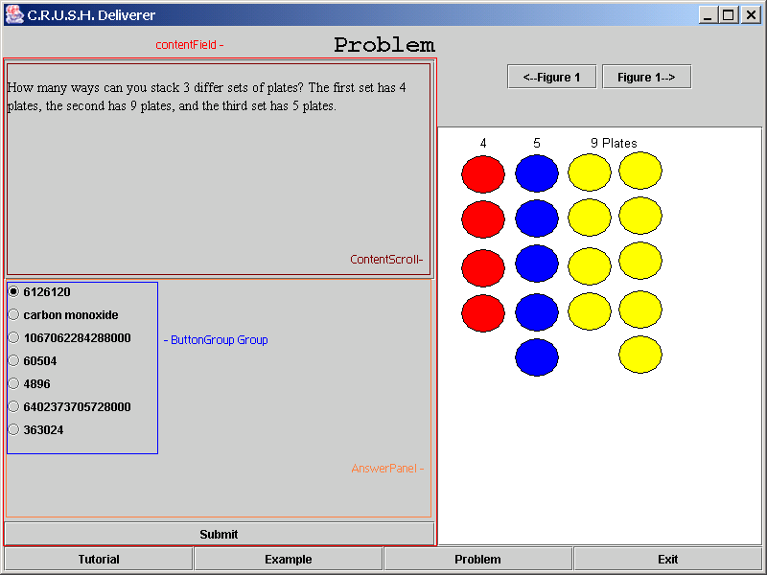
  - Explanation
    - ContentField – Holds the AnswerPanel, as well as the ContentScroll.
    - ContentScroll – holds the content of the question
    - AnswerPanel – holds the possible answers to the question, as well as the Submit button.
    - Group – Groups the radioButtons for the answers
    - Submit – Checks to see if the answer was right, then displays the explaination of the answer in the AnswerPanel
    - The Support Material is the same as TutorialPanel and ExamplePanel

Other
  - The PHP file: The PHPfile takes the supported and the table (ILO_Ttrl_Support, ILO_Exmp_Support, or ILO_Prob_Support) as parameters in the URL. The PHP file then checks what kind of file the support is, if it is a JPEG or a GIF, it calls another PHPfile, to display the image correctly. Otherwise it displays the content of the support.
    - If the uploaded file is an HTML, it is possible to have IMG tags to display multiple images for the support. However, currently, no actions occur when clicks are made, besides the tally that a click made. So one cannot click on hyperlinks, or type text inside a support.

