

The ILMDA Project

Documentation on ILMDA v4.0 Java Classes

Written by
L.D. Miller, T. Blank, L.-K. Soh

February 20, 2004

Computer Science and Engineering

University of Nebraska, Lincoln, NE 68588-0115

E-mail: { lmille, tblank, lksoh }@cse.unl.edu
WWW: http://www.cse.unl.edu/agents/crush
Tel: 402-472-6738
Fax: 402-472-7767

Module: ILO_Interface

Purpose: Provide in interface for an applet or a simulator to an agent, examples, problems, tutorials, and profiles.

Interaction with: ILO_NewApplet, ILO_Simulator, ILO_Prof, ILO_Student, ILO_Tutorial, ILO_Example, ILO_Problem, ILO_UtilOutcome, fuzzyfy, ILO_Agent, ILO_DatabaseCon, ILO_Case

Interaction: The applet or simulator sends the session variables to the Interface, including: who the student is, how much time they spent in each section, how many clicks in each section, etc. The applet or simulator then asks the interface to get an example or a problem. ILO_Inteface does this by using an agent. It passes the current problem-space variables (such as the time spent on a session, the number of mouseclicks, etc.) to the agent, and the agent responds with a set of “ideal” solution-space variables. These variables are fed into fuzzyfy, which finds an actual problem or example from the database, which closely matches the “ideal” problem or example. The Interface also updates all of the Profiles, Tutorials, Examples, Problems, Students, Cases, etc with their new variables, and uses UtilOutcome to determine the success of the agent’s adaptation, and the fuzzy retrieval.

Flow:
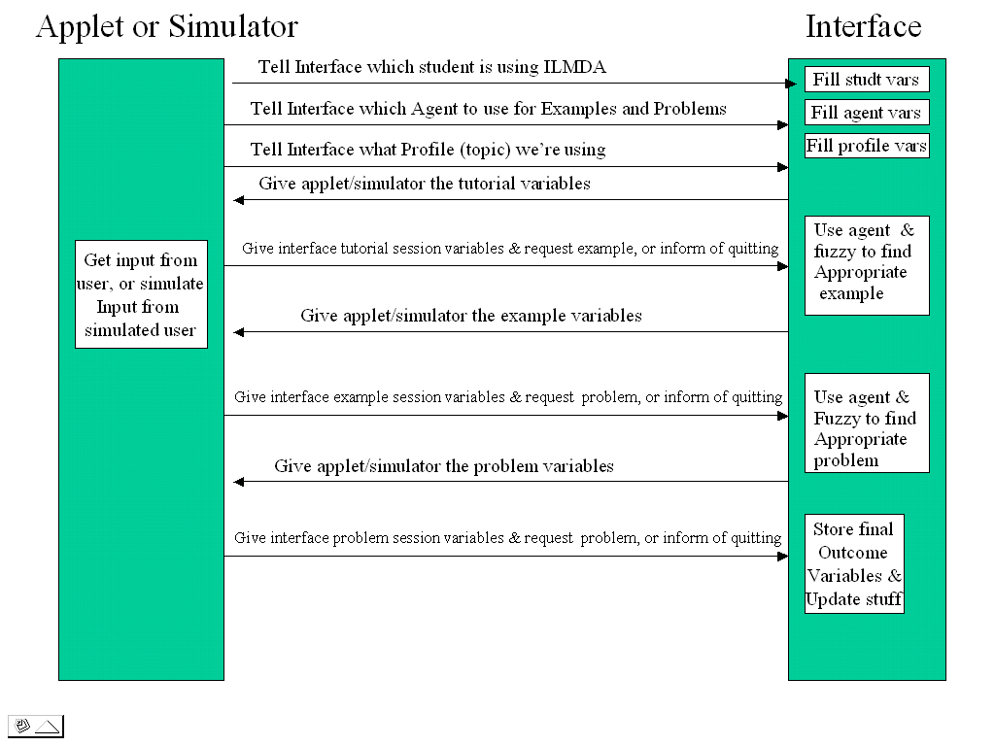

Module: ILO_DatabaseCon

Purpose: Provide an easy-to-use interface to a MySQL database connection.

Interaction with: any class that accesses the ILO database.

Interaction: Simply pass in the Database driver, a URL, username, and password into the constructor. You may then use the methods to execute queries, execute updates, and get specific columns from queries. See Javadocs for documentation.
Module: ILO_NewApplet

Purpose: Provide a GUI interface to ILMDA

Proprietary Sub-Classes: ILO_LoginPanel, _NewUserPanel, ILO_PickTtrlPanel, ILO_TtrlPanel, ILO_ExmpPanel, ILO_ProbPanel, ILO_SectionPanel, ILO_Timer

Interacts with: ILO_Interface

Interaction: Provides a way for users to log into the ILMDA system, lets them select a topic, and presents the content from the topic. ILO_NewApplet keeps track of the users’ time spent in each section, along with the number of clicks, and “back & forth”s the student has. It sends this information to ILO_Interface, to allow the Interface to select an appropriate example and problem for the student. (Also see documentation on ILO_Interface)

Module: ILO_Simulator

Purpose: Provide a way of quickly simulating many sessions from various random students.

Interacts with: ILO_Interface, ILO_DatabaseCon

Interaction: ILO_Simulator randomly selects students of the appropriate type, and assigns session data values for them based on their student type and their background variables (which are based on the student’s type), these session data variables are passed into ILO_Interface. The interface then responds with an example/problem. The simulator decides at each step if the student quit, went on, succeeded, etc, and stores how successful the agent and fuzzyfy were in finding appropriate examples/problems for the students.

Module: ILO_Case (ILO_ExmpCase, ILO_ProbCase, ILO_CaseInput, ILO_CaseOutput)

Purpose: Provide a way of storing case data, and useful methods for comparing cases, and storing/updating cases in the database

Interacts with: ILO_Agent, ILO_DatabaseCon, ILO_UtilSim

Interaction: ILO_Case is composed of two subclasses, ILO_CaseInput, which houses the problem space of the case, and ILO_CaseOutput which houses the solution space of the case. ILO_ExmpCase and ILO_ProbCase are two types of ILO_Case. The latter of which adds one variable, aveScore to the case variables. Each case has a method to compare its input to another case using ILO_UtilSim. This function returns a double value between 0 and 1, with 1 meaning the cases are exactly the same. Each case also has methods to store itself into the database, and to update its variables in the database. When ILO_Agent adapts based on a case, it returns an ILO_CaseOutput class, which contains the solution space for the current case. The solution space basically consists of a set of search keys by which the agent queries the database for the appropriate examples or problems.

Module: ILO_StudentGenerator

Purpose: The purpose of ILO_StudentGenerator is to generate virtual students. These virtual students have the same information that a real student would enter into the ILO_NewApplet. In this way the ILO_Agent has no knowledge that it is in fact interacting with a virtual student rather than a real student.

ILO_StudentGenerator only generates “static” variables. These are variables that a real student would enter only once into the ILO_Interface. The ILO_Simulator generates new “dynamic” variables during each iteration. The static variables generated by ILO_StudentGenerator are:
- aveClick
- aveExmpClicks
- aveExmpTime
- aveGrade
- aveProbClicks
- aveProbTime
- aveExmpToTtrl
- aveProbToExmp
- aveProbToTtrl
- aveSesTime
- aveTtrlTime
- aveTtrlClicks
- gpa

The primary assumption that the Student Generator makes is that students can be divided into nine different Student Types by three different categories of two attributes.
The first attribute is Speed, how fast the student reads and goes through the learning material. Speed also affects how fast the student answers the problems. The three different categories for Speed are: Fast, Medium, and Slow.
The second attribute is Aptitude, how quickly the student learns new ideas and concepts in the learning material. Aptitude is not affected by prior exposure to the topic the learning material covers. The three different categories for Aptitude are: High, Average, and Low aptitude.
As mentioned above the nine different combinations of these three different categories for two attributes make up the student types. A type-1student would have High Aptitude and Fast Speed. A type-9 student would have Low Aptitude and Slow Speed. Please consult the figure below for more information.
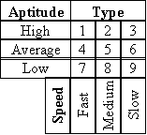
Figure 1. Table of student types used by ILMDA Simulator

When generating variables such gpa or aveTtrlClicks we wanted a non-uniform distribution around some value set by us for each variable. In essence, the value would only be random enough. This value should also vary depending on the Student Type being generated. This is done by providing a mean value for all six categories and using a Gaussian distribution around the mean. A standard deviation is also provided for each set of three categories. Depending on the Student Type different Gaussian distributions are selected. Please consult the figure below for more information.
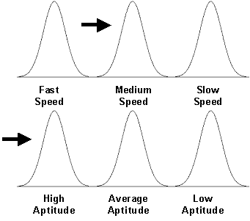
Figure 2. Type-2 Student: High Aptitude and Medium Speed

The actual value on the Gaussian distribution is generated by first taking a random Z value between plus and minus three. The Z value is transformed into an X value using a simple equation found in any Stats text. The Y value corresponding to X value on the Gaussian (i.e. normal) distribution is computed. To insure non-uniformity in our generated values we test them against a randomly generated value between zero and the normal distribution function evaluated at the mean. If the randomly generated value is greater than the Y value of the normal distribution at that X the generated value is discarded and the process repeats. This insures a non-uniform distribution of values around means we set. Please consult the figure below for more information.
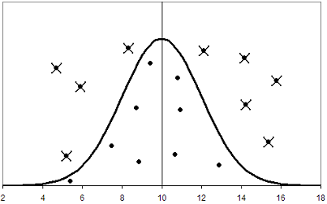
Figure 3. X values are not accepted when their Y value is greater than random Y value

The Student Generator module actually generates non-uniform values for each of the six categories. The two categories corresponding to the student type are selected. The two non-uniform values are then averaged together to determine the final generated value for the static input variable. For certain input variables the non-uniform value from one attribute (Speed or Aptitude) is given more weight.

Interaction with: The ILO database.

Proprietary subclasses: NormalDistribution, StatRandom, ValueGenerator, and StudentValueGenerator

Interaction: The “virtual” students are stored as records in ILO.ILO_Sim_Student, ILO.ILO_Sim_Student_Intr, and ILO.ILO_Sim_Student_Majr tables.

Module: ILO_Agent

Purpose: ILO_Agent is our implementation of the ILMDA architecture. To be part of the Agent architecture an agent must implement the Agent interface. This interface consists of one method.

ILO_CaseOutput adaptNewOutput(ILO_Case newCase, ILO_Case oldCase);

The critical part of this method is that an agent in the ILMDA architecture must return a CaseOutput. This is how the interface gets the search keys (CaseOutput) to find which problem or example to give to the student. The performance of the entire ILMDA architecture is directly proportional to how well these search keys (CaseOutput) are chosen.

The purpose of ILO_Agent is to generate search keys (CaseOutput) for the Interface. The ILO_Agent is currently designed to receive a CaseInput object from the Interface. This CaseInput object consists of the “dynamic” variables recorded from student interactions with the Interface. From this CaseInput object the ILO_Agent generates the corresponding CaseOutput object. Please see ILO_Case for more information on CaseOutput and CaseInput objects.

The ILO_Agent has two algorithms for generating the search keys (CaseOutput). They are case-based reasoning and simulated annealing. These algorithms are encapsulated in the proprietary subclasses UtilAdapt and UtilAnneal. The default algorithm is case-based reasoning.

The ILO_Agent also contains several Learning Modules. These Learning Modules modify the database based on specific criterion. They are standalone modules and any agent in the ILMDA architecture can choose to implement one or more of them. While they have not been rigorously tested, individually they appear to work as intended.

Interaction with: Interface

Direct subclasses: UtilAdapt, UtilAnneal, Learning Modules

Interaction: The agent receives a CaseInput from the Interface. Using this CaseInput the agent generates the search keys (CaseOutput). This CaseOutput is then returned to the Interface.

